**Special Aggregate Functions in SQL**

Special aggregate functions extend beyond the basic **SUM, COUNT, AVG, MIN, MAX** and are used for **statistical, analytical, and ranking** operations in SQL. These functions are particularly useful in **data warehousing, OLAP (Online Analytical Processing), and business intelligence** for advanced data analysis

**Examples**:

* **VAR_POP(x)**: Variance for the entire population.
* **STDDEV_POP(x)**: Standard deviation for the entire population.
* **COVAR_POP(x, y)**: Covariance for two variables.
* **CORR(x, y)**: Correlation coefficient between two variables.
* **RANK()**, **DENSE_RANK()**: Assigns ranks to rows within a partition.

**(a) VARIANCE and STANDARD DEVIATION**

* Measures the **spread or dispersion** of values in a dataset.
* Helps to determine how much data deviates from the mean.
* **Functions:**
  + VAR_POP(x): Population variance.
  + VAR_SAMP(x): Sample variance.
  + STDDEV_POP(x): Population standard deviation.
  + STDDEV_SAMP(x): Sample standard deviation.

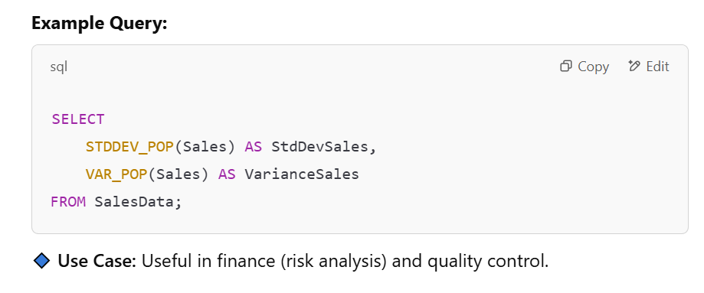

**(b) COVARIANCE and CORRELATION**

* **COVAR_POP(x, y)**: Measures the relationship between two variables.
* **CORR(x, y)**: Measures the strength and direction of the relationship (returns values between -1 and 1).

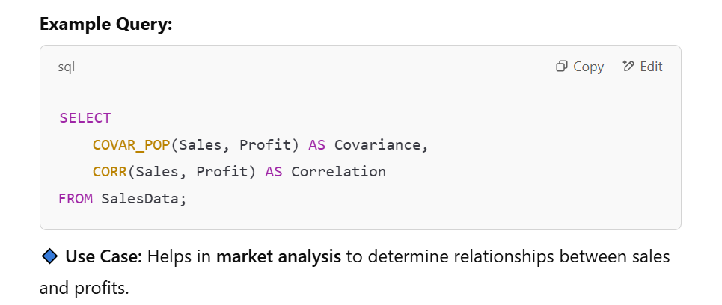

**2. Ranking Aggregate Functions**

These functions assign **ranks** to rows based on a specific order.

**(a) RANK()**

* Assigns a rank to each row **with gaps** when there are duplicates.
* Rows with the same value get the same rank, but the next rank is skipped.

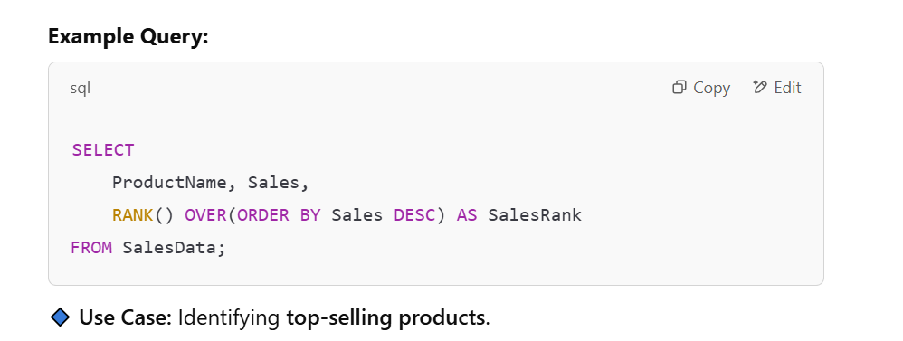

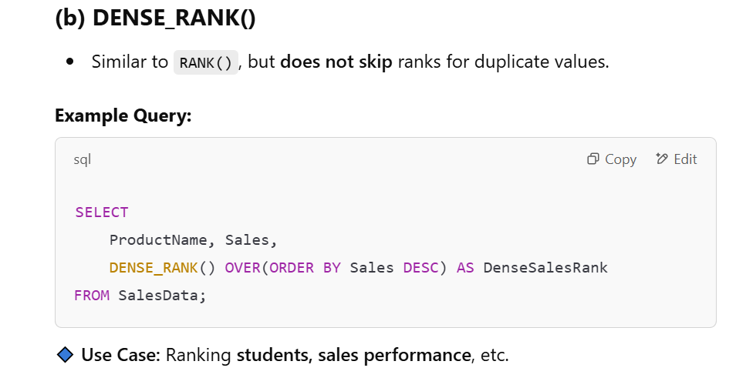

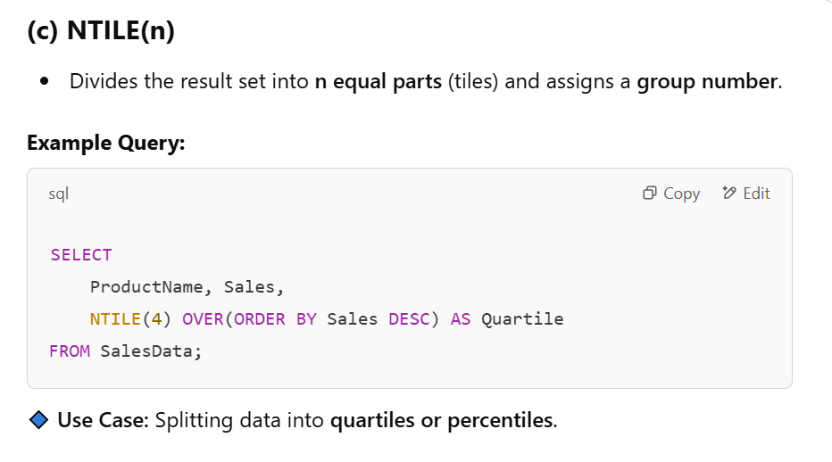

**3. Regression Aggregate Functions**

Used in **predictive analytics and trend analysis**.

**(a) REGR_SLOPE and REGR_INTERCEPT**

* Used for **linear regression analysis**.
* **REGR_SLOPE(x, y)**: Slope of the best-fit line.
* **REGR_INTERCEPT(x, y)**: Y-intercept of the best-fit line.

